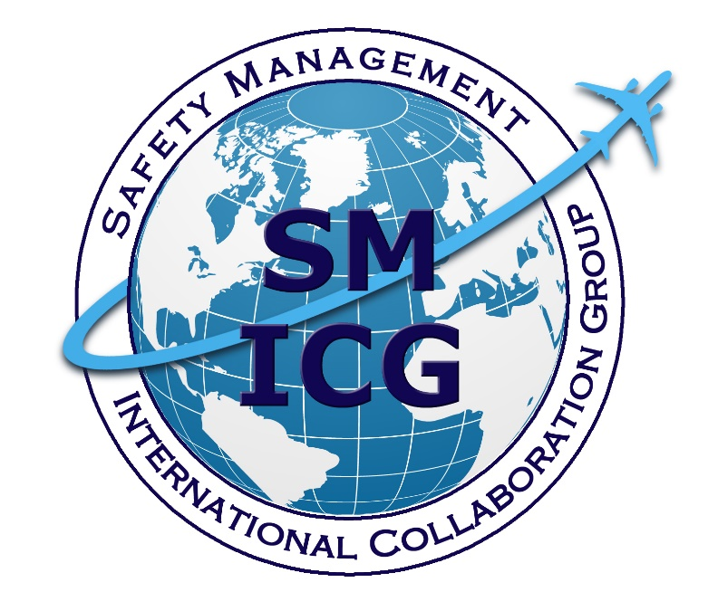

**Guidance for Implementing or Improving Voluntary Safety Reporting at the State Level**

**January 2025**

This paper was prepared by the Safety Management International Collaboration Group (SM ICG). The purpose of the SM ICG is to promote a common understanding of Safety Management System (SMS) / State Safety Programme (SSP) principles and requirements, facilitating their application across the international aviation community. In this document, the term “organisation” refers to an aviation service provider, operator, business, and company, as well as aviation industry organisations; and the term “authority” refers to the regulator authority, Civil Aviation Authority (CAA), National Aviation Authority (NAA), and any other relevant government agency or entity with oversight responsibility.

The current core membership of the SM ICG includes the Aviation Safety and Security Agency (AESA) of Spain, the National Civil Aviation Agency (ANAC) of Brazil, the Bermuda Civil Aviation Authority (BCAA), the Civil Aviation Authority of the Netherlands (CAA NL), the Civil Aviation Authority of New Zealand (CAA NZ), the Civil Aviation Authority of Singapore (CAAS), Civil Aviation Department of Hong Kong (CAD HK), the Civil Aviation Safety Authority (CASA) of Australia, the Direction Générale de l'Aviation Civile (DGAC) in France, the Ente Nazionale per l'Aviazione Civile (ENAC) in Italy, the European Union Aviation Safety Agency (EASA), the Dominican Republic Civil Aviation Institute (IDAC), the Finnish Transport and Communications Agency (Traficom), the Irish Aviation Authority (IAA), Japan Civil Aviation Bureau (JCAB), the United States Federal Aviation Administration (FAA) Aviation Safety Organization, Transport Canada Civil Aviation (TCCA), United Arab Emirates General Civil Aviation Authority (UAE GCAA), and the Civil Aviation Authority of United Kingdom (UK CAA). Additionally, the International Civil Aviation Organisation (ICAO) is an observer to this group.

Members of the SM ICG:

* Collaborate on common SMS/SSP topics of interest
* Share lessons learned
* Encourage the progression of a harmonized SMS/SSP
* Share products with the aviation community
* Collaborate with international organisations such as ICAO and civil aviation authorities that have implemented or are implementing SMS and SSP

Please send any questions regarding this product to [smicg.share@gmail.com](mailto:smicg.share@gmail.com). For further information regarding the SM ICG or to download SM ICG products, please visit SKYbrary at[http://bit.ly/SM ICG](http://bit.ly/SMICG).

# Table of Contents

1. Introduction 1

2. Background 1

3. Definitions 3

4. Structure 3

5. General Processing of Reports 4

6. Interfaces 6

Integrated Management System 6

Safety Risk Management Processes 6

Just Culture and Safety Culture Bodies 6

Processing of Reports Through State or Government Channels 6

Accident Investigation Authority 7

7. VSRS Key Principles, Best Practices/Lessons Learned 7

Confidentiality and Trust 7

Non-Punitive Reporting 7

Accessible Reporting 8

Ease of Reporting 8

Independent Processing 8

Data Quality 9

Feedback and Acknowledgment 9

Promotion and Engagement 9

Collective Safety Data Processing and Analysis 10

VSRS Oversight and Continuous Improvement 10

8. Communication and Promotion 10

9. References and Resources 11

Appendix A: VSRS Poster A-1

# Introduction

International Civil Aviation Organisation (ICAO) Annex 19 states, “*5.1.3 States shall establish a voluntary safety reporting system (VSRS) to collect safety data and safety information not captured by mandatory safety reporting systems.*”

This document is applicable to all State authorities responsible for implementing a VSRS.

A **Voluntary Safety Reporting System (VSRS)** is a reporting system established to collect safety data and safety information not covered by the mandatory safety reporting system. These reports go beyond typical incident reporting and tend to highlight latent conditions, such as inappropriate safety procedures or regulations, human errors, etc. (ICAO Doc 9859, Safety Management Manual, Fourth Edition, Section 5.2.6.1)

A VSRS provides the State with information on reporting culture, reporting rates, and quality of reports and should complement other safety information-sharing programs by identifying hazards that may lead to an accident. The overall objective of the system is to affect positive safety outcomes.

# Background

A VSRS is integral to a well-functioning State Safety Program (SSP), providing an opportunity for both individuals and organisations to report hazards, safety-related issues, concerns, and incidents that may otherwise remain unreported. These reports go beyond mandatory reporting and tend to illuminate latent conditions and new safety issues not already specified in mandatory reporting requirements.

Voluntary reports are often the only source of information on a particular hazard or event.

Ideally, a VSRS should complement the existing mandatory reporting systems. While reporting is critical to the success of any safety system, VSRSs could encompass various other supplementary reporting methods such as: collaborative mechanisms within service providers and the State, reporting managed by independent entities and investigative authorities, etc.

Many States have set up a successful VSRS and have acquired a wealth of knowledge on the components of a successful voluntary system. Other States are using their established mandatory reporting systems to foster a positive culture of reporting safety issues. At the same time, some States have faced challenges and learned lessons along the way.

Voluntary reporting is successful when a State embraces a Just Culture and understands the importance of establishing an atmosphere of trust, where its individuals are encouraged to report essential safety-related information and issues. This approach fosters the resolution of safety issues through corrective action rather than through punishment or discipline.

Just Culture is a critical step to building this trust in which reporters are not punished for actions, omissions, or decisions taken by them that are commensurate with their experience and training, but in which gross negligence and willful violations are not tolerated.

However, a Just Culture is not a “no-accountability” culture. VSRS processes should describe acceptable and unacceptable behaviours and indicate which types of behaviours are unacceptable relative to activities. Robust process should also include the circumstances under which disciplinary action would apply in the event willful violations and gross negligence is evident.

Reporters must be informed about examples of what is acceptable and unacceptable behaviour and must understand the reporting and general processing steps of the reports. This establishes the atmosphere of trust where the State will focus on the context of the event and systemic factors that are present, rather than the reporter’s actions. This will support prevention of the same type of event across the system. A reporter in a Just Culture must feel comfortable to report potential safety issues without fear of retribution.

However, setting up a well-functioning and trusted VSRS is not simple. It goes beyond setting up the reporting system and databases and includes the building of trust between the reporter and the entities collecting the reports.

Figure 1 illustrates the relationship between voluntary reporting and the safety culture sub-components. The presence of a Just Culture is important to enable an effective Reporting Culture. The remaining three sub-components of Safety Culture are important to the success of voluntary reporting. When mistakes are learned from, appropriate changes are made, and the State adapts effectively to those changes, the State demonstrates a Flexible Culture. As the State continuously collects and analyses relevant data and actively disseminates safety information, it is demonstrating an Informed Culture.

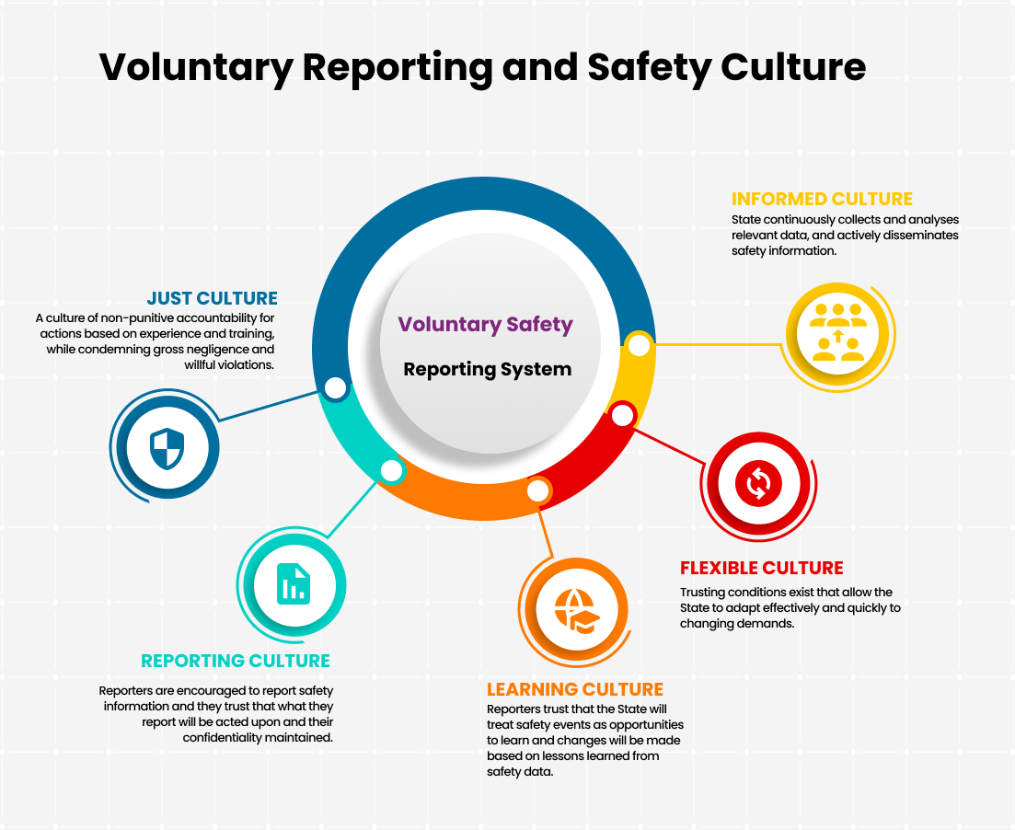

**Figure 1: Relationship Between Voluntary Reporting and Safety Culture Sub-Components[1]**

# Definitions

The [SM ICG Safety Management Terminology](https://skybrary.aero/sites/default/files/bookshelf/32973.pdf) document contains a comprehensive list of terms and definitions. It provides a common set of safety management related terms and definitions for use by the civil aviation community and to assist in effective communication and safety information sharing. The SM ICG encourages the civil aviation community to use these terms and definitions in their safety management-related activities.

# Structure

The State VSRS in most cases will be managed by the Civil Aviation Authority (CAA) or the Safety Investigation Authority. Alternatively, the VSRS may be managed by an independent entity entrusted by the State.

The State may also integrate the VSRS system with the mandatory safety reporting system to form a single safety reporting system; however, the principles of a Just Culture should remain intact.

The individual(s) in charge of the VSRS should work in a structure that operates independently of other departments within the CAA. An independent structure within the CAA is important to ensure the reporters information is kept confidential with the aim of enhancing Just Culture and confidence in the system.

The independent nature of the structure should begin at the stage of collecting reports. It should continue as reports are de-identified, classified, and analysed. The initial assessment of the report should begin during the collection and validation phase when the report is classified based on acceptable and unacceptable safety behaviours. Only departments with immediate safety responsibilities should be included in the assessment or processing of a voluntary report. Forwarding safety information to relevant departments within the CAA must be discreetly managed so that it is consistent with the rules on confidentiality and Just Culture. In essence, information from reports should be used strictly for the purpose of improving aviation safety only.

Internal procedures will be necessary to describe how confidentiality is ensured, how analysis is conducted, the type of safety information to be forwarded to other departments, and how the VSRS interacts with other CAA processes.

# General Processing of Reports

A State website, such as the CAA website, may serve as the voluntary safety reporting portal. The reporting portal is the front end of the VSRS, where users interact with the system and submit their reports. Inclusion of the portal prominently on the State website may enhance accessibility and provide immediate access to other information embedded in the site. The portal to the VSRS can provide other useful information to the reporter, such as links to relevant legislation, protections, learning opportunities, examples of acceptable and unacceptable behaviours, and safety-related communication designed to encourage reporting.

Information should be visible on the portal that provides instruction for the use of the system. In addition, the purpose of the VSRS and guidance on what a reporter may expect once their report is made (i.e., feedback) should be included. Figure 2 shows a graphical representation of the general processing of reports.

During the processing of the reports, there may be instances where the reporter may need to be contacted to seek clarification if insufficient or unclear information is provided in the report. Subsequently, a visit to the location to obtain more information or to verify claim/facts will ensure a meaningful and accurate analysis is completed before processing the report.

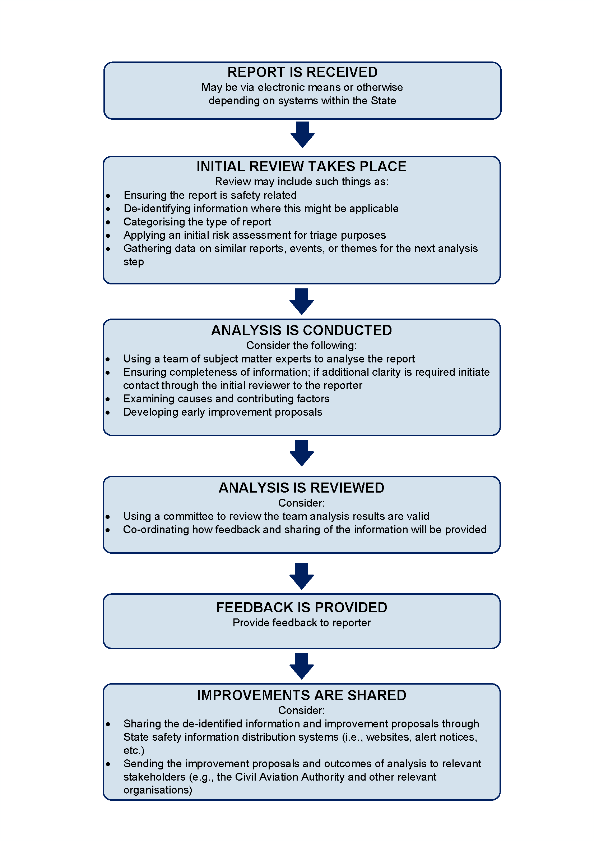

**Figure 2: A Graphical Representation of General Processing of Reports**

# Interfaces

VSRS Interfaces drive actions at the State level, influencing internal aspects such as State practices, policies, and procedures, as well as external functions such as oversight and safety promotion. These should effectively address the most critical safety concerns within the aviation system.

## Integrated Management System

* As an indication of a mature management system, the State should have the ability to share information from different domains (e.g., safety, security, health). An integrated risk management process arises when the appropriate sharing of information and associated risk mitigating actions cross separate domains that have had little previous interaction in this regard.
* Occasionally, valid reports may be received through the wrong channel (due to the reporter's interpretation of or familiarity with which reporting tool to use, especially voluntary versus mandatory reports, or aviation safety versus occupational versus whistleblowing and/or security), which may require forwarding or sharing with the appropriate channel for processing.
* Safety data collected through multiple VSRSs should be integrated at the State level. Different authorities within a State typically collecting voluntary safety reports per their individual management systems are encouraged to share de-identified information at the State level.

## Safety Risk Management Processes

* Safety risk profiles can be developed when integrating VSRS information to safety risk management processes, using State, industry, and public sources. This can help States identify areas to prioritise.

## Just Culture and Safety Culture Bodies

* In States where an independent Just and Safety Culture body is in place, the VSRS should interface with this body to ensure appropriate protection of reporters and application of Just Culture principles.

## Processing of Reports Through State or Government Channels

* To maintain and manage the integrity of the VSRS, the State may process reports categorised as unacceptable behaviours, such as willful violations and gross negligence, through additional internal or external instituted proceedings. For example, fraud could have individual or systemic safety implications such as cases where persons or organisations provide false information and/or documents. Such reports should be deferred to the appropriate State or government channels.
* Similarly, States may ensure that their aviation authorities and their competent authorities for the administration of justice cooperate with each other through administrative instruments or agreements.
* These administrative instruments will seek to ensure the correct balance between the need for proper administration of justice, on the one hand, and the necessary continued availability of safety information, on the other.

## Accident Investigation Authority

* The investigation of Annex 13 accidents and serious incidents is the responsibility of an independent Safety Investigation Authority. The term “occurrence” as used in the Occurrence Reporting System therefore includes accidents, serious incidents, and other incidents.
* Close liaison is needed between the authority competent for occurrence reporting and the Safety Investigation Authority for the State. Interface arrangements may be subject to a memorandum of understanding between the two authorities.

# VSRS Key Principles, Best Practices/Lessons Learned

The following are the key principles of an effective VSRS. Included in this section are the best practices/lessons learned that relate to the key principles. These items should be considered when establishing a State-level VSRS.

## Confidentiality and Trust

Reporters must be certain that their identity is protected, and that information will not be used against them; otherwise, they will be reluctant to report their mistakes.

The VSRS process should enable trust by providing anonymity, particularly where legislation does not protect the confidentiality of the reporters’ identities.

### Best Practices/Lessons Learned:

* Systematically de-identify confidential reports.
* Take into account national rules on freedom of information and personal data protection to ensure reporters’ protection.
* Communicate the confidential aspect of the reporting system to foster trust and a positive safety culture.
* Offer the option of anonymous reporting.
* Protect reporter by limiting access to the system.

## Non-Punitive Reporting

The reporter must be protected against legal, administrative, or disciplinary sanctions, except in case of gross negligence, willful violations, or criminal activity.

### Best Practices/Lessons Learned:

* Ensure that the VSRS is appropriately non-punitive in nature.
* VSRS should enable reporting of hazards and self-made errors without retribution.
* Design barriers in the system to mitigate the potential to pursue disciplinary action.
* Ensure that the VSRS process can delineate gross negligence, willful misconduct, or criminal activity from non-punitive errors and violations.
* Explain that cases of unacceptable behaviour will not be subject to protection of consequences if false information or documents are submitted (especially with the intent to mislead the authority or damage reputation).
* Design controls within the VSRS process describing circumstances under which a report may be redirected from the system.
* Explain and promote the program’s intent and the reporting process; stress the importance of non-punitive reporting to all stakeholders.

## Accessible Reporting

The systematic approach to safety management at the State level requires that voluntary reporting be targeted at all sectors of aviation, including those without SMS, and to members of the public.

### Best Practices/Lessons Learned:

* Where possible, collect information on the same occurrence from different perspectives or reporting systems, both voluntary and mandatory, to provide for a complete analysis and understanding of events, enabling data-driven decision making.
* To the best extent possible, automate the process to match reports on the same occurrence from multiple sources.

## Ease of Reporting

Submitting a report should be as easy as possible for the reporter. The reporting forms or reporting system should be readily available to anyone wishing to file a report.

### Best Practices/Lessons Learned:

* Reports should be easy to complete, provide adequate space for narrative, and make maximum use of pre-filled selections.
* The forms or reporting system should encourage safety improvement suggestions, such as how to mitigate the issue.
* Enable various reporting formats (e.g., online and online forms, paper reporting forms, e-mail contact).
* Enable uploading of media including video and audio files.
* Ease of reporting and using accessible media platforms would certainly increase reporting, however, organizations should be mindful that the data transmitted via these platforms may be accessible by the providers of these services if protections are not in place.

## Independent Processing

The aim, wherever possible, should be to establish and maintain an independent VSRS process.

### Best Practices/Lessons Learned:

* May consider the use of a separate entity to manage the VSRS or define a structure and rules of engagement within the authority to maintain independence.
* Establish independence to maintain confidentiality, objective analysis of occurrences, and feedback to appropriate departments, other authorities, and the aviation community, as needed.
* It may not be possible to identify or engage all participants for each and every report.

## Data Quality

The data quality checking process plays a crucial role in ensuring the accuracy and reliability of the reported information submitted to the VSRS. This mechanism helps to maintain the integrity of the data, ensures transparency, and enhances the overall effectiveness of the reporting system.

### Best Practices/Lessons Learned:

* Verify the accuracy, completeness, and consistency of the reports submitted to help identify and correct errors, ensuring that the information is of high quality.
* If possible, conduct peer reviews by evaluating reports using individuals with similar expertise or experience to ensure the accuracy and validity of the information. Peer reviews add an extra layer of scrutiny and validation to the reporting process, enhancing the credibility of the reports.

## Feedback and Acknowledgment

To encourage further submission of reports, the State should clearly acknowledge receipt and where possible provide periodic status updates and a closure/conclusion to the reporter.

### Best Practices/Lessons Learned:

* States may assign a tracking number.
* Whenever possible, provide feedback on the actions taken in response to a report in a timely manner to the reporter directly but also in the form of collective feedback to the reporting community.
* Provide justification and rationale on safety improvements.

## Promotion and Engagement

To encourage effective VSRS participation, all participants should be familiar with the process and its deliverables.

### Best Practices/Lessons Learned:

* Engage with all participants to raise awareness on the VSRS process, non-punitive reporting, confidentiality, and examples of cases to (or not to) report.
* Encourage organisations to foster a culture of safety and continuous improvement through voluntary reporting.
* Disseminate aggregated analysis of the VSRS with the aviation community in a timely manner. A variety of dissemination methods should be used to achieve maximum exposure (e.g., monthly newsletters, periodic summaries, safety bulletins published on the internet). This will motivate people in further reporting voluntary safety issues, hazards, and self-made errors. Include outcomes that had a positive effect on aviation safety.
* Consider disseminating pertinent reporting information such as: reporting rates, quality of reports, response times, resolution rates, and safety outcomes.

## Collective Safety Data Processing and Analysis

The analysis of collated safety data is a critical component of a successful VSRS. Accomplishing this effectively will lead to positive safety outcomes.

### Best Practices/Lessons Learned:

* Collate reports to help identify trends, perform analysis, and identify indicators of potential risks and threats.
* Evaluate data and information periodically that have touchpoints with other organisations throughout the State, which will give State-level insights and/or actions to consider.
* Conduct analysis cohesively with interfacing systems such as the mandatory reporting system and Annex 13 reporting information.
* Ensure that the analysis feeds into risk-based processes and activities at the State level.

## VSRS Oversight and Continuous Improvement

Oversight of the VSRS system is an essential component of its continued effectiveness. Conducting audits of the system and its outputs as well as monitoring its overall performance will ensure that it remains effective.

### Best Practices/Lessons Learned:

* Evaluate the VSRS via internal and external audit processes which should include evaluation of the reporting system and risk management system’s performance to assess how the safety information is best utilised.
* Assess reporting culture during the audit activities to ensure that Just Culture principles are followed.
* Revise and enhance State policies and procedures with lessons learned which may be subsequently adopted by the aviation participants.
* Define performance indicators to measure effectiveness and efficiency of the VSRS. Consider indicators such as reporting rates, quality of reports, response times, resolution rates, and safety outcomes. Measure these regularly to identify areas needing improvement.
* Conduct stakeholder surveys or include the topic of VSRS in safety culture surveys conducted by the State authorities. This is to solicit stakeholder expectations/sentiments and feedback on aspects of the VSRS including awareness of the VSRS and reporting principles, ease and accessibility of reporting, confidentiality and trust, and satisfaction with follow-up actions.

# Communication and Promotion

Promoting the VSRS is crucial to ensure reporters understand the program’s inner workings, have confidence in the report processing, and feel protected. The State needs to cultivate a culture of trust for the reporter to comprehend the system’s purpose, recognise its value in mitigating or eliminating operational risks, and appreciate its role in driving positive aviation safety outcomes.

System promotion needs to ensure the inclusion of the points that are most relevant to the stakeholders such as:

1. Differences between mandatory and voluntary reporting
2. How confidentiality will be maintained
3. Details of non-punitive aspects of the report
4. Addressing acceptable and unacceptable behaviours
5. Promoting safety reports in a positive manner to assure and create a level of trust

Effectively communicating information from the voluntary reporting system to the aviation community is essential. States may create communication campaigns, educational packages, brochures, posters, videos, etc. in response to safety outcomes. These resources are intended for internal and external stakeholders. Appendix A contains a sample VSRS poster.

States have effectively utilised various methods to initiate and maintain safety promotion, leveraging data gathered from the VSRS. Communicating the outcomes of reports is crucial for the reporters. State authorities might consider developing processes that extend beyond automated acknowledgments to include feedback on outcomes. Highlighting successes and reporting on mitigated safety events can build confidence in the system. Such promotional activities can motivate individuals to enhance the reporting of safety hazards and occurrences. A range of information dissemination methods can be employed to achieve this.

Some examples of successful communication methods are:

* Newsletters
* Safety briefings
* Safety visuals (posters, signs, videos, etc.)
* Safety bulletins and alerts
* Safety campaigns
* Onsite conferences, workshops, or webinars
* Incorporation into syllabus of training courses
* Participation in aviation society meetings and industry forums

# References and Resources

* [SM ICG Safety Management Terminology](https://skybrary.aero/articles/safety-management-terminology)
* [SM ICG Voluntary Occurrence Reporting](https://skybrary.aero/articles/voluntary-occurrence-reporting)

* [ICAO Doc 9859, The Safety Management Manual (SMM), 4](https://www.icao.int/safety/SafetyManagement/Pages/GuidanceMaterial.aspx)[th](https://www.icao.int/safety/SafetyManagement/Pages/GuidanceMaterial.aspx) [Edition](https://www.icao.int/safety/SafetyManagement/Pages/GuidanceMaterial.aspx)

# Appendix A: VSRS Poster

The following page contains a sample poster that can be used in promoting VSRS. The poster is also available for separate download on the [SM ICG SKYbrary site](https://skybrary.aero/enhancing-safety/sm-icg-safety-management-products).

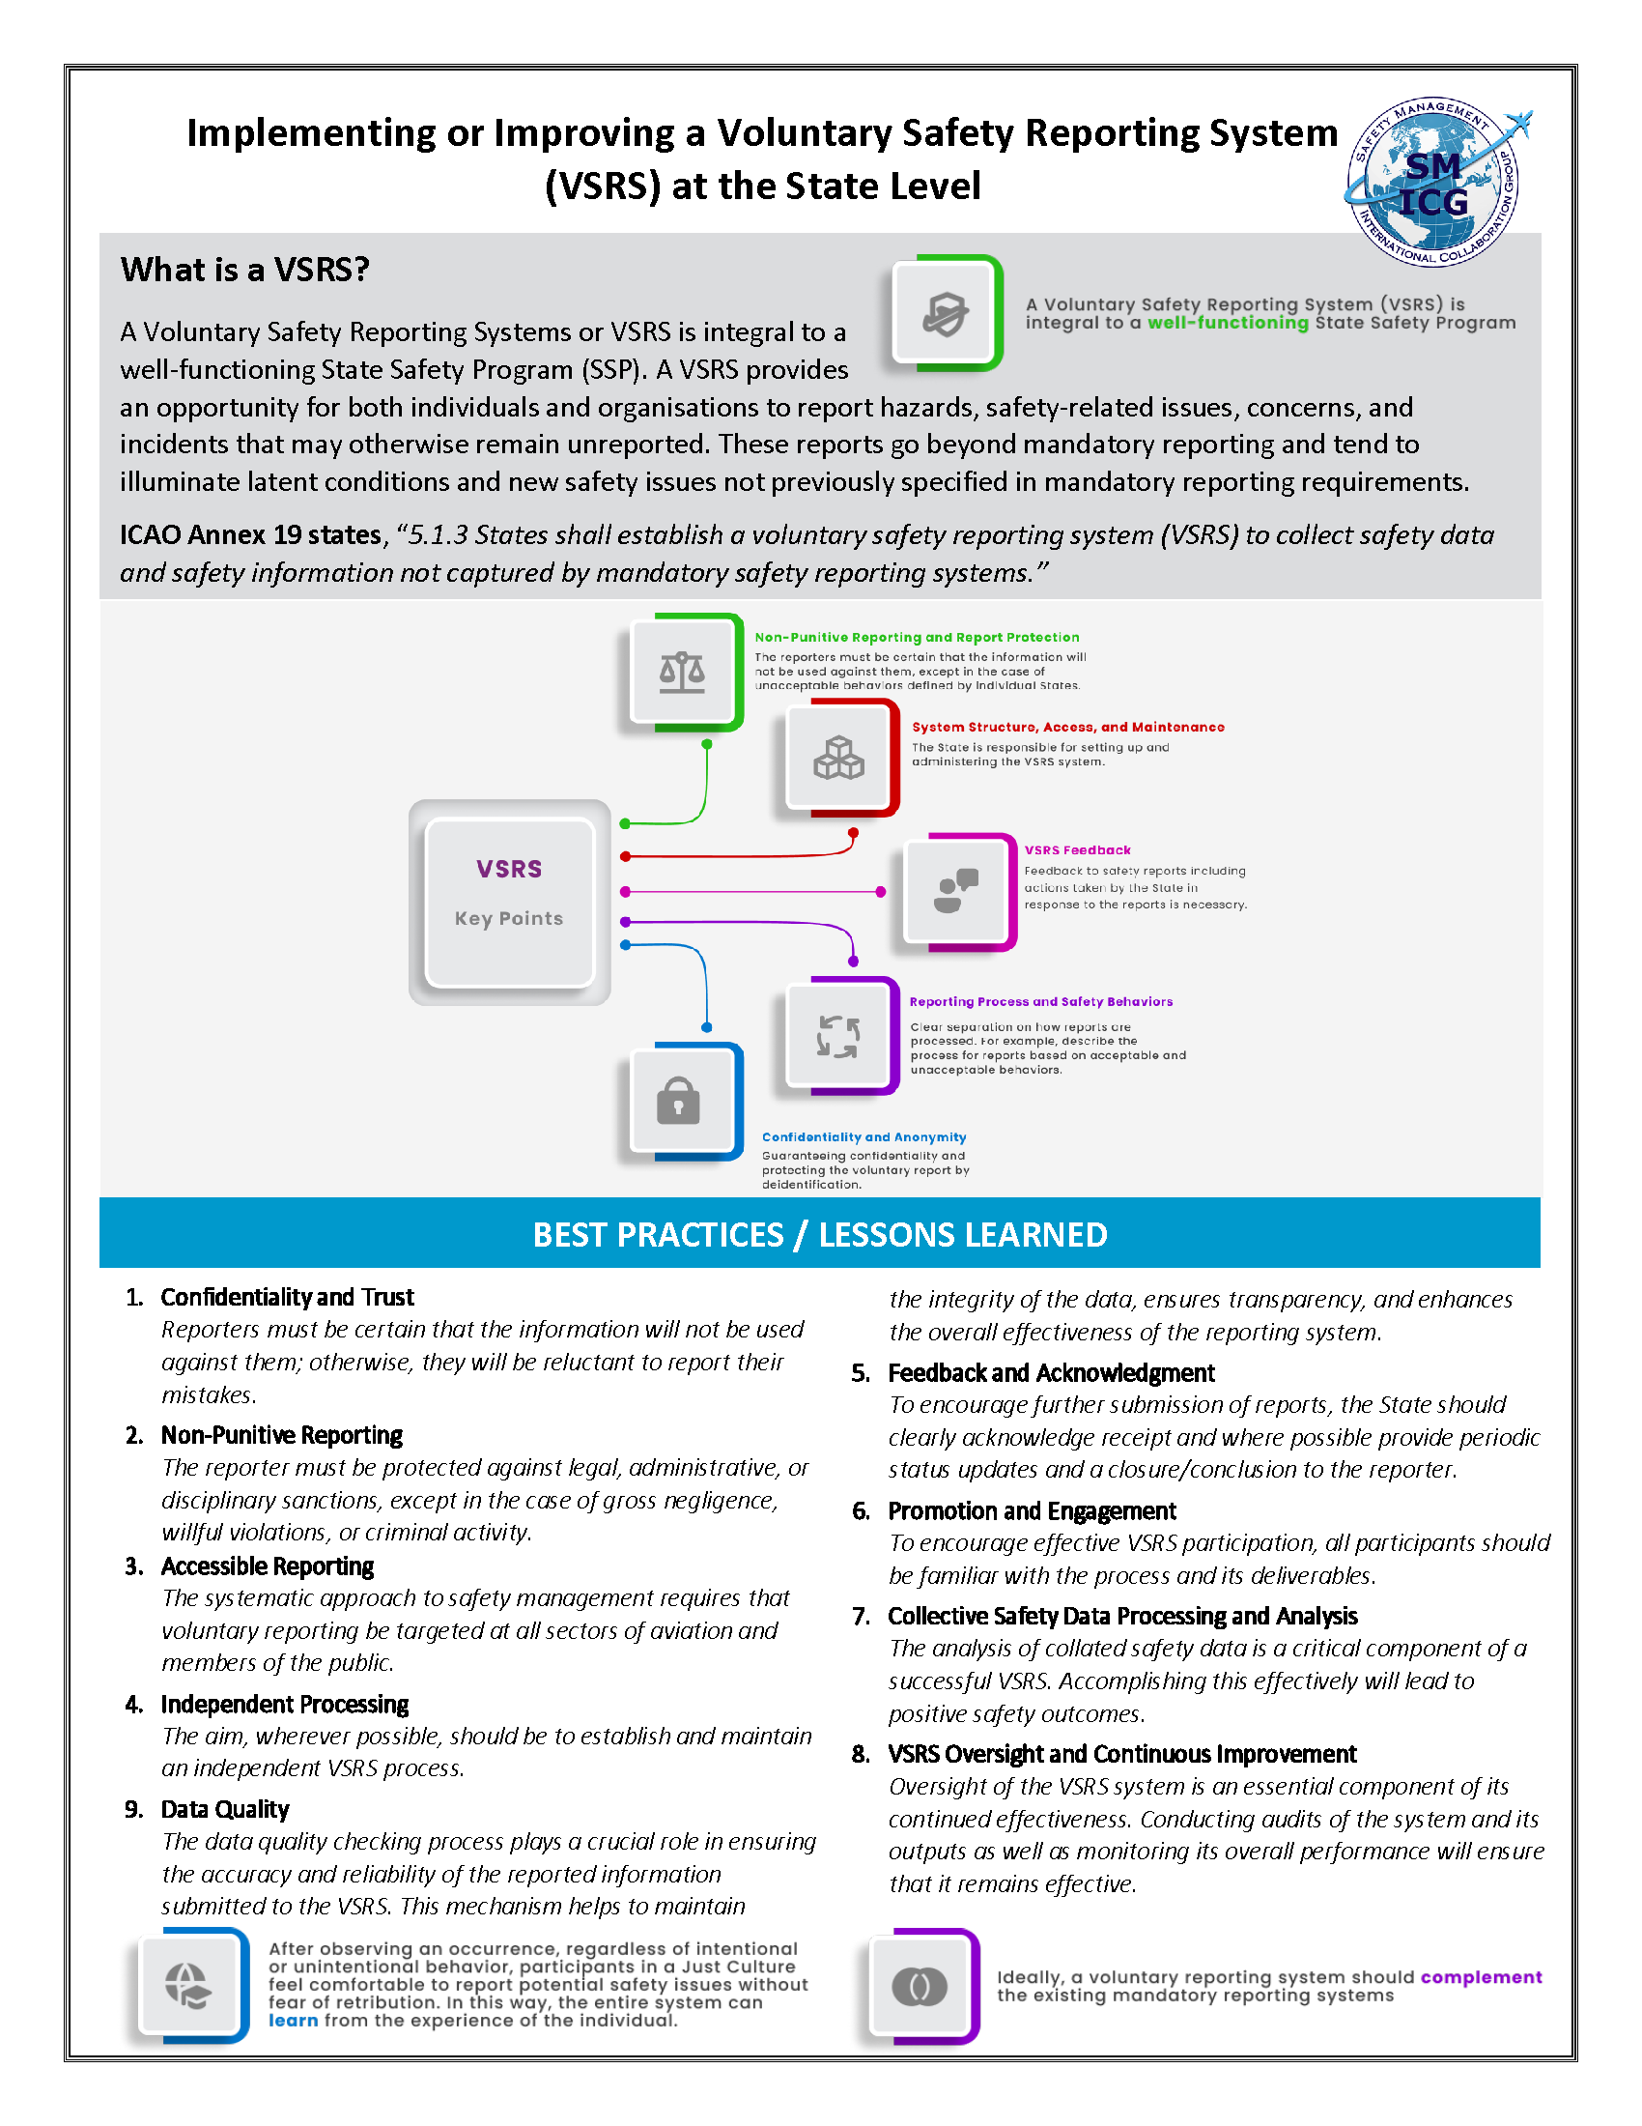

1. Figure 1: Relationship between Voluntary Reporting and Safety Culture Sub-Components was adapted from the Safety Culture work of James Reason.